Supplementary Material
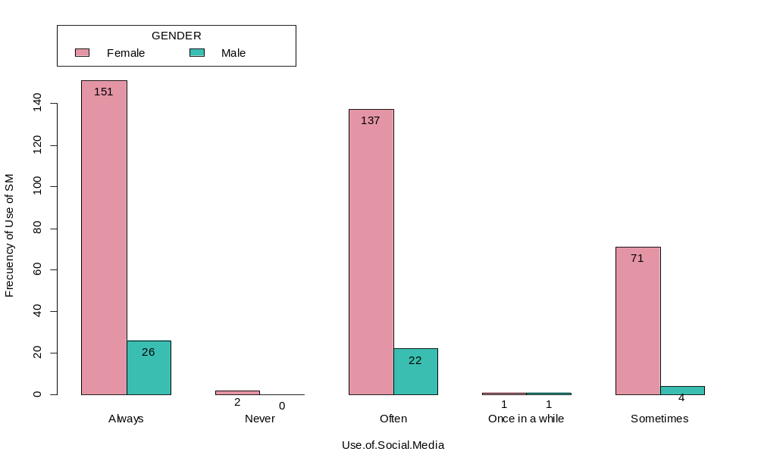
Figure S1. Frequency of use of Social Media (SM) by men and women in a sample of Ecuadorian users in Manabi, Ecuador.

Table S1. Type of violence that vulnerable groups receive in SM.
Violence in SM to vulnerable groups | Female | Male | Total
Sexual Harassment | 13 | 2 | 15
Violent comments in relation to people and their body shape | 174 | 21 | 195
Violent comments in relation to their sexual orientation | 22 | 5 | 27
Intimate comments and images that involve them or friends and family | 16 | 0 | 16
Other | 31 | 5 | 36
Violent comments about their political orientation | 103 | 20 | 123
Don’t want to recall | 3 | 0 | 3

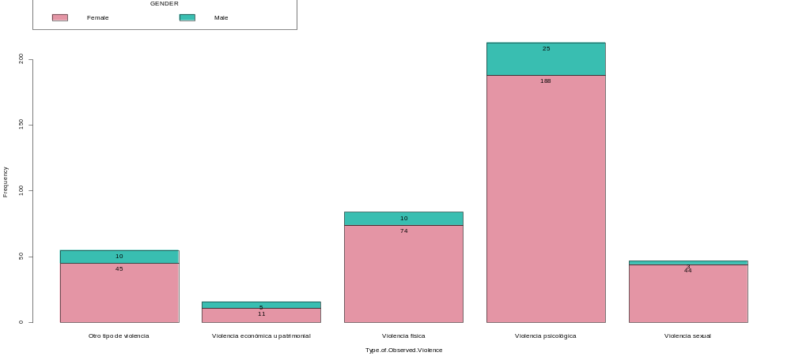
Figure S2. Prevalence of type of violence received by vulnerable groups

